PROJECT TITLE
(ARIAL 16 Bold_UPPER CASE)

Note: Please get vetted by the Project Guide before sending this synopsis to KSCST

Project Reference No.: 49S_BE_XXXX
(Arial 12 Capitalize Right Align)

(Arial 12 Capitalize Left Align_ sentence case)
College : Name of the College/ Institution / University
Branch : Department of
Guide(s) : Guide 1 (Dr./ Prof.)
Guide 2
Student(s) : Student 1 (Mr. / Ms.)
Student 2 (Mr. / Ms.)
Student 3 (Mr. / Ms.)
Student 4 (Mr. / Ms.)

Keywords: (Arial 12 Bold)
Collision Tolerant, Mechanical Gimbal, Inspection, drone cage, unmanned sewage inspection. (Arial 12)

Introduction: (Arial 12 Bold)
Industrial pipeline and sewage inspections pose significant risks to human safety. To address this (Arial 12)

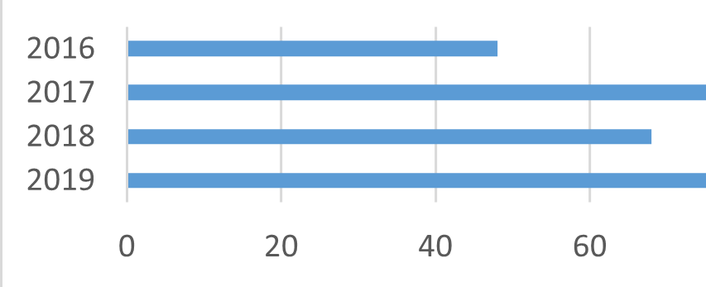
Figure 1: Title/name of the figure (Arial 10)
Literature Survey:

Objectives: (Arial 12 Bold)
- List the objectives 1 of project
- List the objectives 2 of project
- List the objectives 3 of project
- List the objectives 4 of project (Arial 12)

Methodology: (Arial 12 Bold)
The project (Arial 12)

Result and Conclusion: (Arial 12 Bold)
In conclusion, (Arial 12)

References: (Arial 12 Bold)
- (Arial 12) (IEEE citation format)

Future Scope: (Arial 12 Bold)
The future scope of this project includes: (Arial 12)

