
KARNATAKA STATE COUNCIL FOR SCIENCE AND TECHNOLOGY
Indian Institute of Science campus, Bengaluru
Telephone: 080 – 23341652, 23348848 || Email: spp@kscst.org.in
Website: www.kscst.org.in/spp.html or https://kscst.karnataka.gov.in/en
FORMAT FOR STUDENT PROJECT PROPOSAL FOR THE
49th SERIES OF STUDENT PROJECT PROGRAMME
(Handwritten proposals will not be accepted, please fill all the details in this MS word file, insert images / diagrams wherever necessary. Convert to pdf file, get it approved from the project guide / head of the department and principal of your institution. Keep ready the scanned pdf file of 1) Declaration and Endorsement 2) details of processing fees made and fill-up the Google Form.
https://forms.gle/iXiR81MyoLWn871x7
Name of the College:

Project Title:

Branch:

Theme (as per KSCST poster):
(The project proposals shall mandatorily be from one of the broad themes / areas. Visit website www.kscst.org.in/spp.html)

Name(s) of project guide(s):
- Name: Prof. / Dr. / Mr. / Mrs.
Email id:
Contact No.:
- Name: Prof. / Dr. / Mr. / Mrs.
Email id:
Contact No.:
Name of Team Members (Strictly not more than four students in a batch): (Type names in Capital Letters as provided in your college)
(Please paste the latest passport size photograph adjacent to your respective names)
Name:
USN No.:
Email id:
Mobile No:

Name:
USN No.:
Email id:
Mobile No.:

Name:
USN No.:
Email id:
Mobile No.:

Name:
USN No.:
Email id:
Mobile No.:
Team Leader of the Project:
Name:
USN No.:
Email id:
Mobile No.:
Processing Fee Details (Through Online Payment only):
(processing fee of Rs. 1180/-)
Please furnish the payment details in the format provided in the last page of the proposal.
Date of commencement of the Project:

Probable date of completion of the project:

Timeline Structure
Task | Start Date | End Date | Duration | Milestone achievable
Project Initiation
Research Phase
Development Phase
Testing Phase
Submission of PPT and Abstract to KSCST for conducting mid-term evaluation  (Upload to Google Form) | Middle of March – 2nd Week of April 2026
Final Review
Project Submission
Submission of Project Completion Report to KSCST (Upload to Google Form) | April / May 2026

Scope / Objectives of the project:

Methodology:

Note: In case of fabrication work in the project, an engineering drawing with dimensions / detailed design should be attached to the proposal.
Expected Outcome of the project:

Is the project proposed relevant to the Industry / Society or Institution?

Yes / No:
If yes, please provide details of the industry / institution and contact details:

(Note: Preference will be given to those projects relevant to the industry / institution. Hence be specific in giving detailed information). Is the industry extending support - technology / funds / use the final product, please specify.
Can the product or process to be developed in the project be taken up for filing a Patent?
Yes / No:

Prior Art search done?
Yes/No:
Note: If your answer is “Yes”, you may contact Patent Information Centre of KSCST. For more details, email: pic@kscst.org.in
Budget details (break-up details should be given):
Note: KSCST will provide nominal grant support for carrying out the project by students if selected by the project selection committee.
Budget | Amount
a) Materials / Consumables (Please specify) | 0.00
b) Labor (Describe) | 0.00
c) Travel (Describe) | 0.00
e) Miscellaneous (Please specify) | 0.00
Total | 0.00

Any other technical details (Please specify):

SPP Coordinator (Identified by the college):
Note: To be identified by the principal of the institution. The project proposals must be submitted to KSCST through SPP coordinator designated by the principal.

Name: Prof. / Dr. / Mr. / Mrs.
Email id:
Contact No.:

(Name & Signature of  SPP Coordinator with Seal) | Name and signature of the  Project Guide with Seal:
Email id: | Email id:
Contact No.: | Contact No.:

DECLARATION
(From Project Students)
(To scan this page and enclose in the project proposal)

We, the project team hereby declare that the details enclosed in the project proposal (Title of the Project: ………………………………………………………………………….., Branch: ………………………., College: ………………………………………………………..) are true and correct to the best of our knowledge and belief. We undertake to inform the Karnataka State Council for Science and Technology (KSCST) of any changes to the project title or team members' names immediately through our project guide or the SPP Coordinator of our institution.
Additionally, we declare that the project work is original and not a result of copying or purchasing. We are committed to completing the project independently, with support from our faculty and project guide, while utilizing the facilities provided by the college. We will not engage in plagiarism and pledge to be sincere and dedicated in executing and completing the project as proposed.
We understand that if any of the above information is found to be false, untrue, or misleading, we may be held liable. We authorize the sharing of the project information contained in this proposal with KSCST, Bengaluru.
We acknowledge that the project team must exhibit and demonstrate the project, participate in the mid-term evaluation of sanctioned projects, and engage with experts. Additionally, we must exhibit the project at the Annual State-Level Poster Presentation and Exhibition, if selected. Should our team fail to participate in the mid-term evaluation or the Annual Exhibition (if selected), we understand that the supported project funds will be returned to KSCST.
We also enclose the endorsement form for KSCST, Bengaluru.
Name of the students with USN No. Signature with date

(Name & Signature of  SPP Coordinator with Seal) | Name and signature of the  Project Guide with Seal:
Email id: | Email id:
Contact No.: | Contact No.:

ENDORSEMENT
(From College, endorsement to be taken in the institution / Department Letter head)
(To scan this page and enclose in the project proposal)

This is to certify that 1) Mr. / Ms.……...................., 2) Mr. / Ms. ……………................
3) Mr. / Ms. …………………............, 4) Mr. / Ms. ……………………................, are bonafide student(s) of Department of ......................................................., in the degree program of our institution. If the project proposal submitted by these students under the 49th series of Student Project Programme is selected by KSCST, we will provide the requisite laboratory / Computer / infrastructure support in our college / Institution. Further we also take necessary steps to see that the project team will exhibit / demonstrate their project in the mid-term evaluation of project and in the Annual State-Level Poster Presentation and Exhibition (if selected). If the student team fails to send the completed project report or fails to attend the evaluation in mid-term evaluation of sanctioned projects or fails to attend the Annual State-Level Poster Presentation and Exhibition (if selected), the supported project amount will be returned to KSCST.

(Name & Signature of  Project Guide with Seal) | (Name & Signature of  SPP Coordinator with Seal) | (Signature of HoD  with Seal)
Email id: | Email id: | Email id:
Contact No.: | Contact No.: | Contact No.:
 |  | (Signature of the Principal with Seal)
 |  | Email id:
 |  | Contact No.:

DETAILS OF PROCESSING FEES MADE THROUGH
NEFT / UPI PAYMENT
(Note: Include this page in the softcopy of the student project proposal. The student team shall furnish the details in the Google Form. It is informed to the students to 1) keep ready the softcopy of the project proposal and other documents and 2) Furnish the payment made details as processing fees and 3) update the details in the Google Form on the same day of payment made to KSCST by NEFT / UPI payment).
For finance related queries, please contact KSCST accounts section: 080 – 23341652, 23348848, email: finance@kscst.org.in

- TITLE OF THE PROJECT | :
- NAME OF THE TEAM LEADER | :
- EMAIL ID | :
- CONTACT MOBILE NO. | :
PAYMENT MADE DETAILS
- BANK REF. NO. / UTR NO. / UPI No. (12 digits) | :
- TRANSACTION ID | :
- NAME OF THE SENDER / ACCOUNT HOLDER and CONTACT NUMBER | :
- NAME OF THE BANK | :
- PROCESSING FEES | : | Rs. 1,180/- (Inclusive of 18% GST)
- DATE OF PAYMENT MADE | :
- TIME | :
- MODE OF PAYMENT MADE  (NEFT / UPI, PLEASE SPECIFY) | :

(Name & Signature of  the team leader) | (Name & Signature of  Project Guide / SPP Co-ordinator / HOD  with Seal)
KARNATAKA STATE COUNCIL FOR SCIENCE AND TECHNOLOGY
Indian Institute of Science campus, Bengaluru
49th SERIES OF STUDENT PROJECT PROGRAMME (SPP)
(Note: This page is for information about bank details of KSCST to the student team and college / institution and not to include this page in the project proposal softcopy)

BANK ACCOUNT DETAILS OF KSCST
Name and address of the Institution | Karnataka State Council for Science and Technology, IISc Campus, Bangalore -560012
Account holder’s name / Designation | Secretary, Karnataka State Council for Science and Technology
Bank Account No. & Name of the bank | Current A/C No. 0683201000024  Canara Bank, IISc Campus Branch, Bangalore-560012
IFSC Code | CNRB0000683
MICR Code | 560015023
Bank Branch Address | Canara Bank, Indian Institute of Science, Bangalore-560012

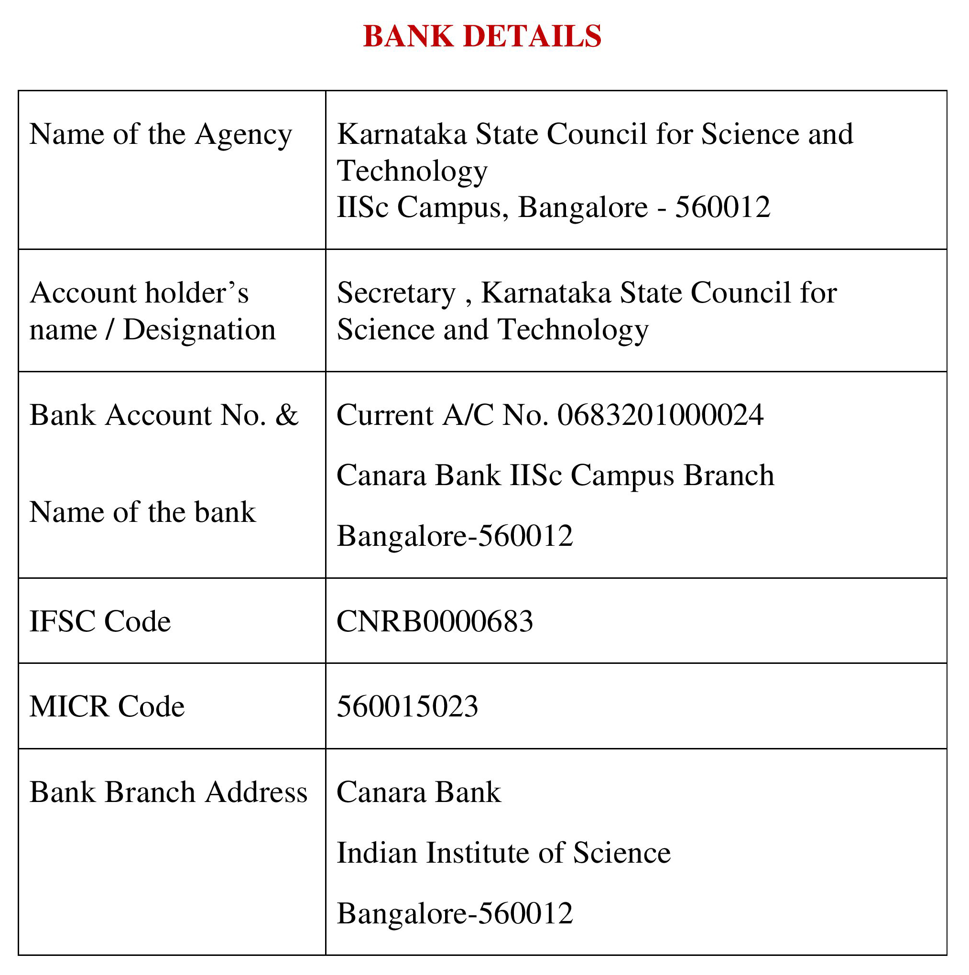
Note: For finance related queries, please contact KSCST accounts section: 080 – 23341652, 23348848 during office hours between 3.00 pm to 5 pm, email: finance@kscst.org.in with a copy to spp@kscst.org.in
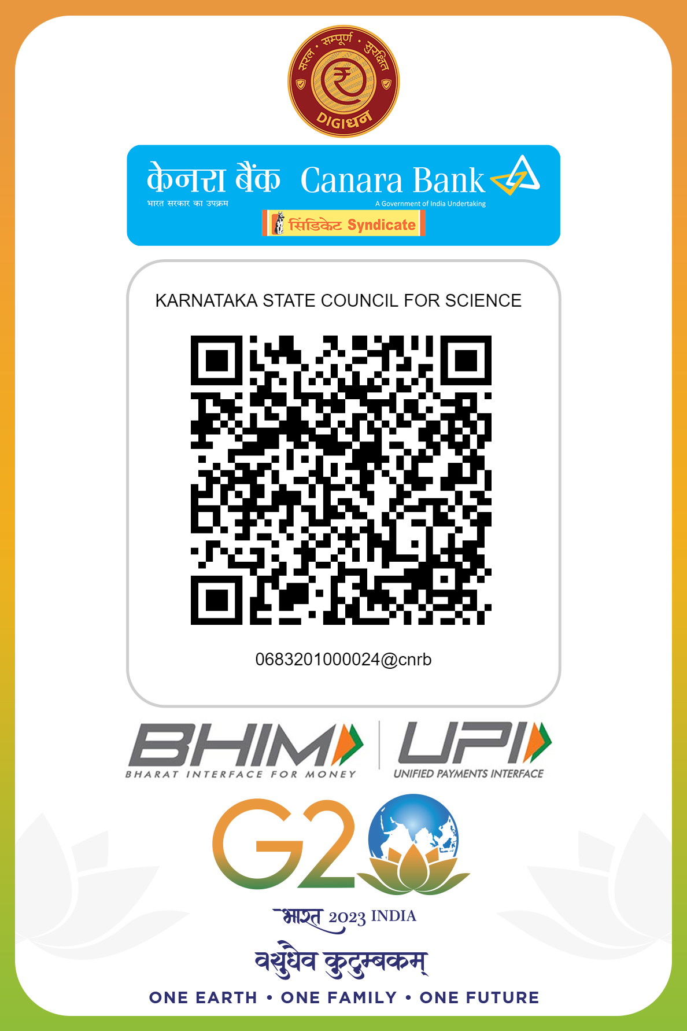
Note: For finance related queries, please contact KSCST accounts section: 080 – 23341652, 23348848 during office hours between 3.00 pm to 5 pm, email: finance@kscst.org.in with a copy to spp@kscst.org.in

